Docker Compose

1.Docker version and docker compose version
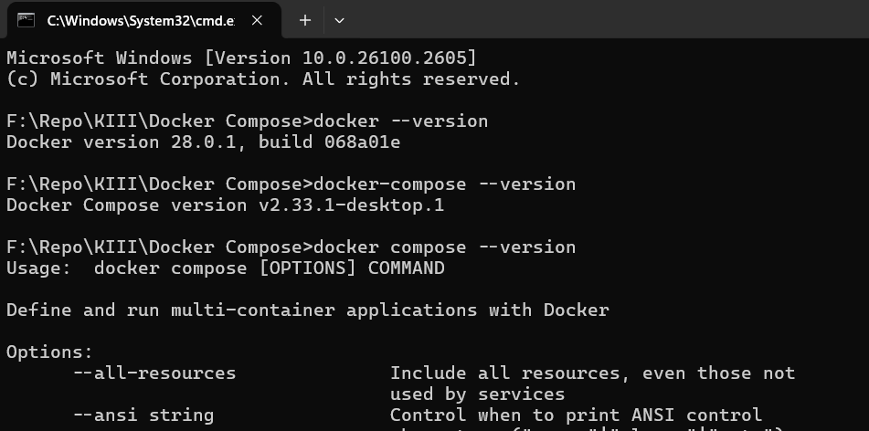
2.Creating the directory and the app.py file writing the code, and testing it locally before docker
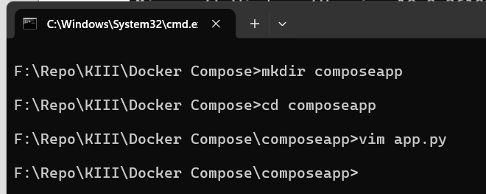

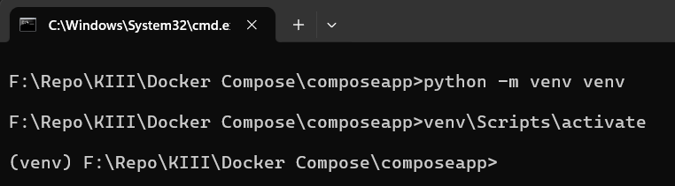

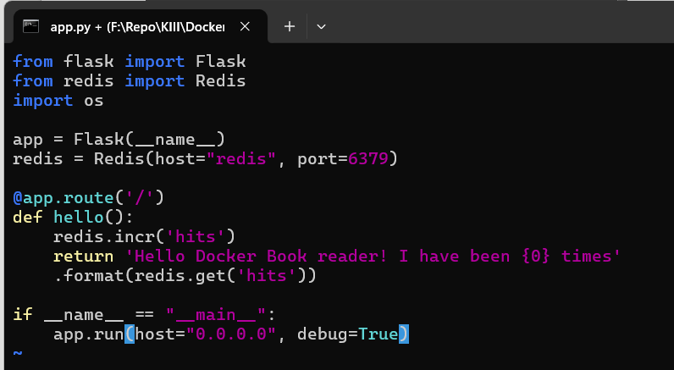

3.
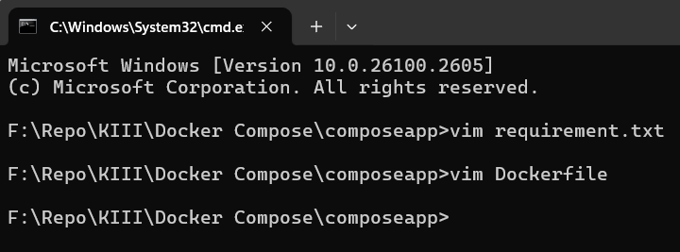

4.Dockerfile
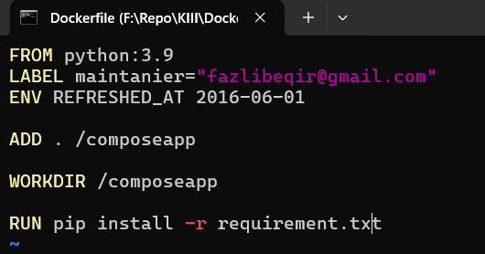

5.Building the dockerfile
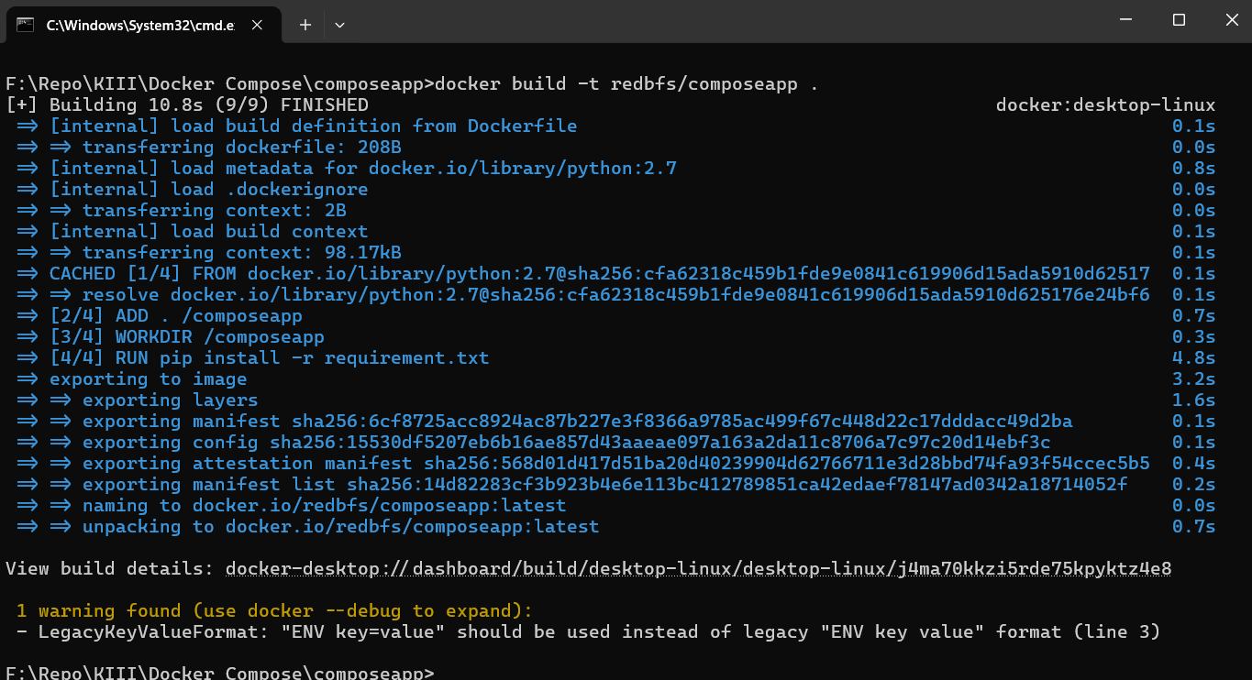
6.docker-compose.yml file
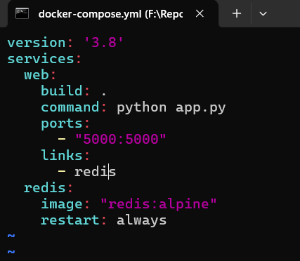

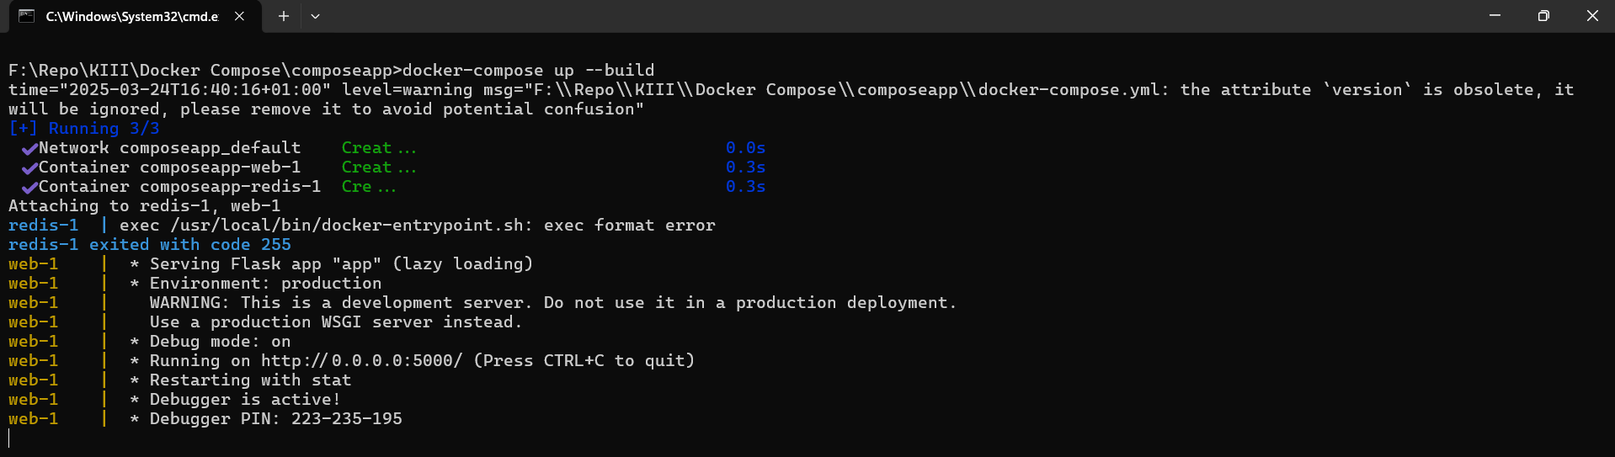
7.docker-compose up with build

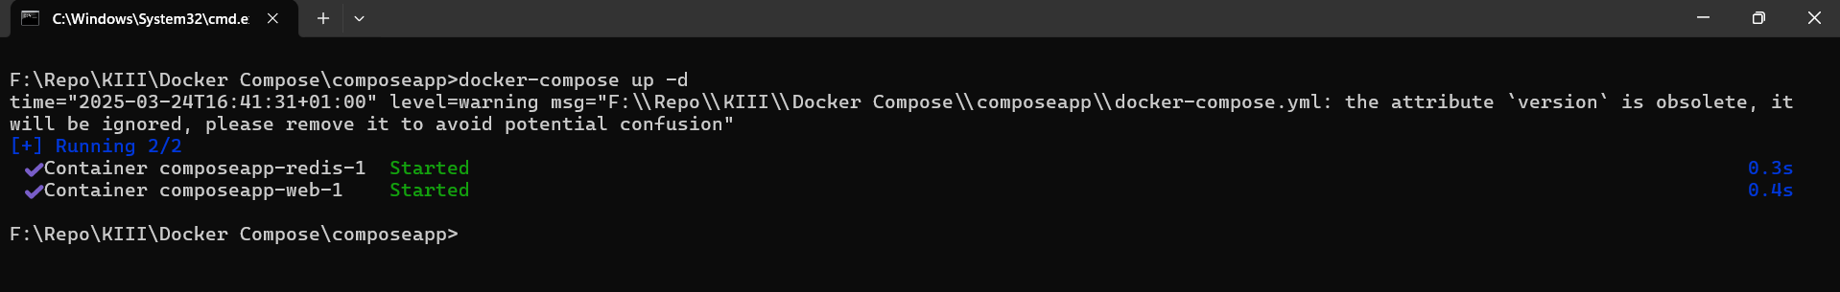
8. docker-compose up with build and demonizieng

9. Watching the containe are they running
10.The logs for redis and flask(web) and the browser
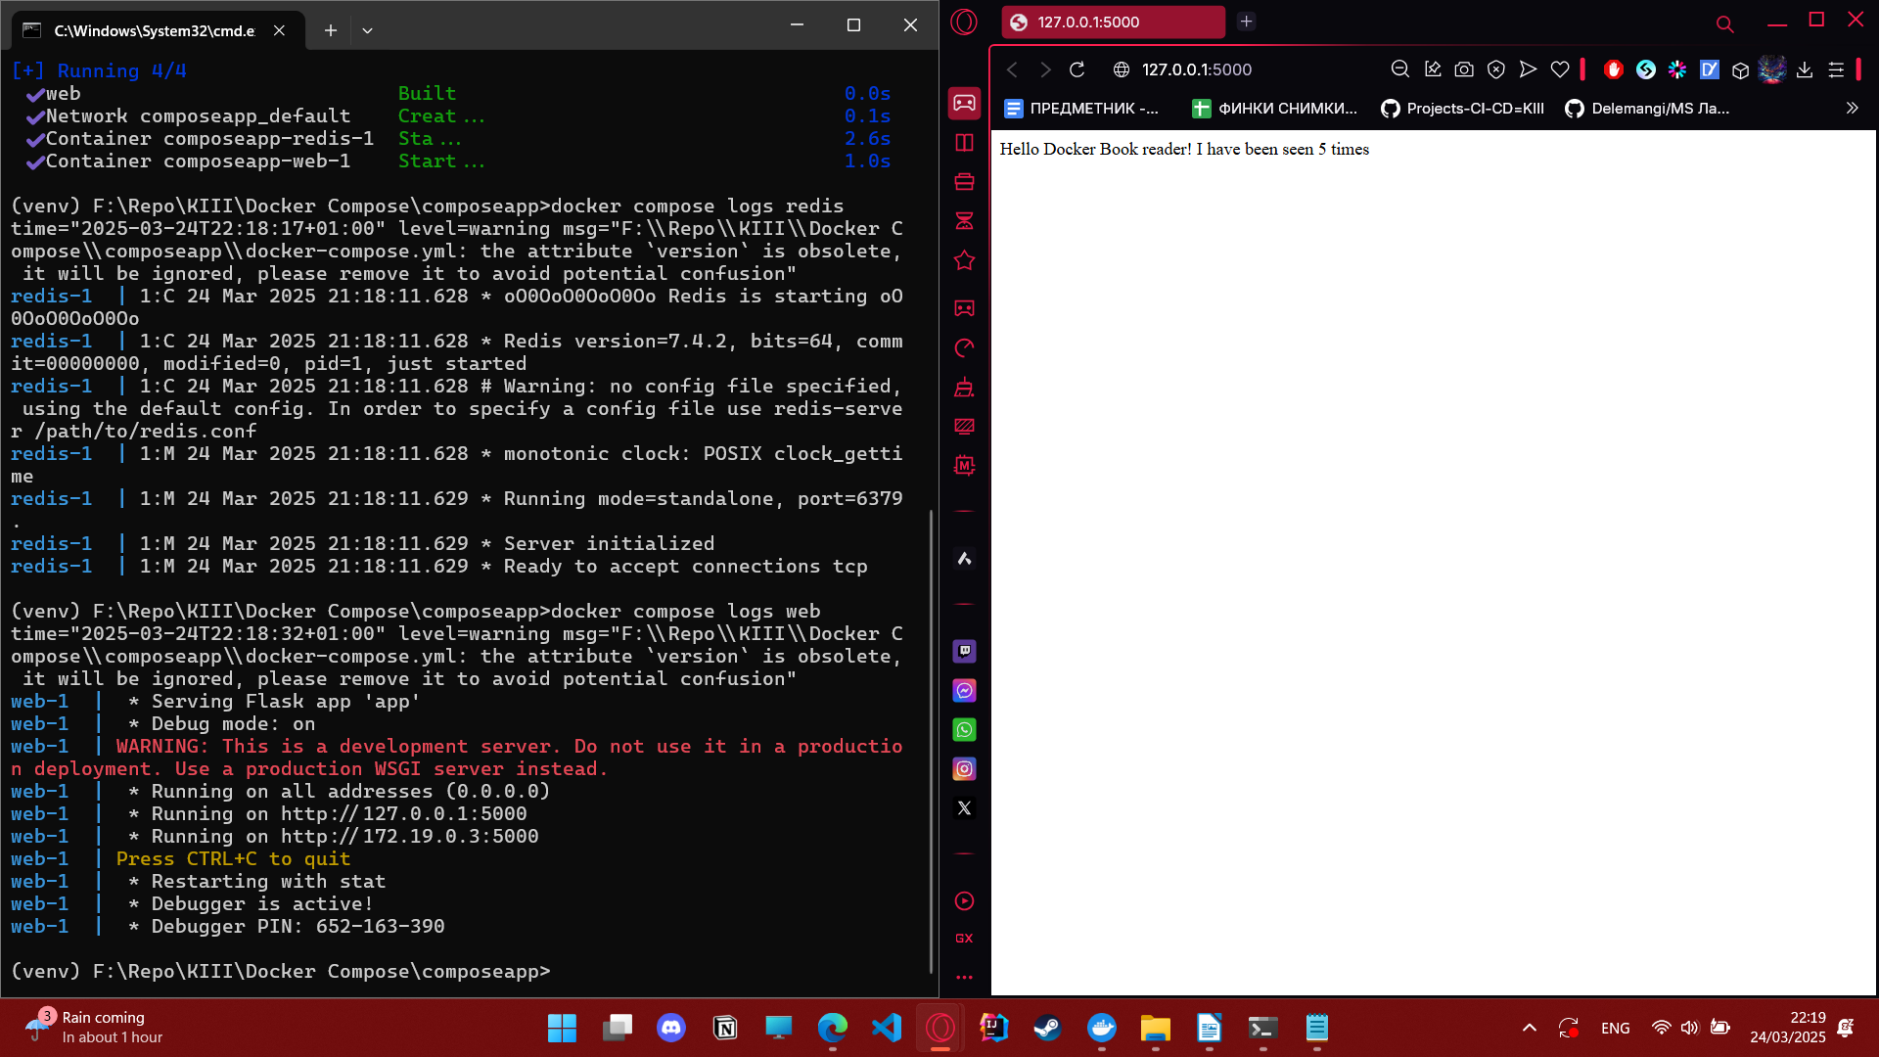

11. All logs for the web app from one command
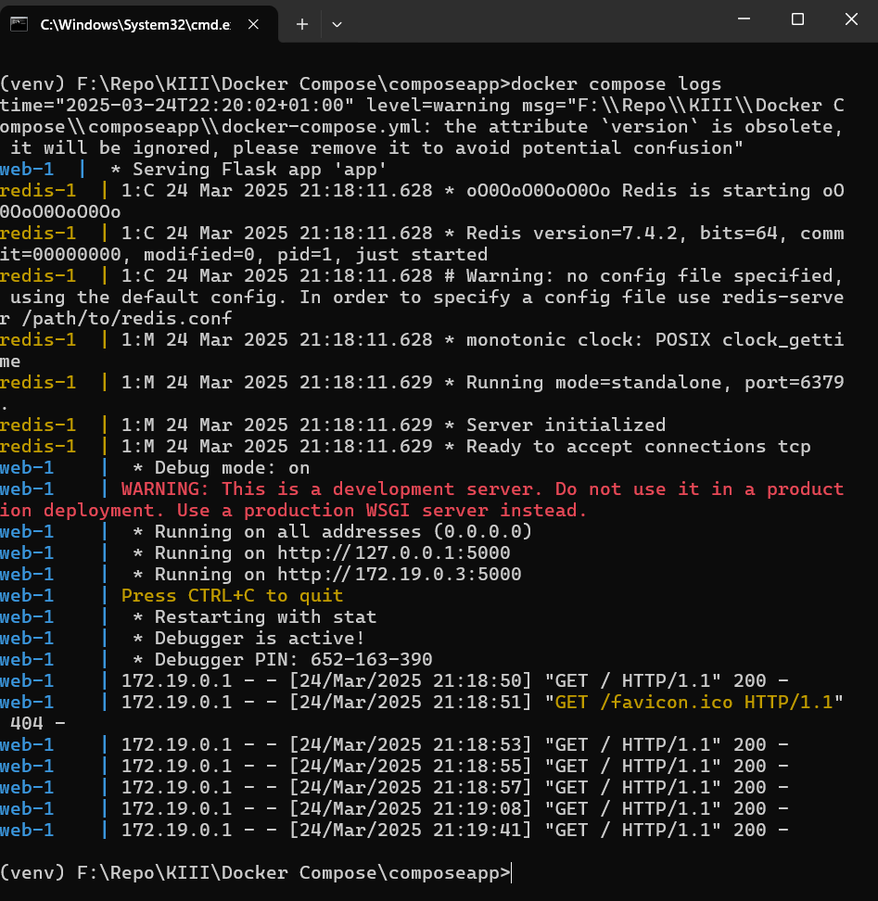
12.Stoping the containers and we see they arent active in docker-compose ps
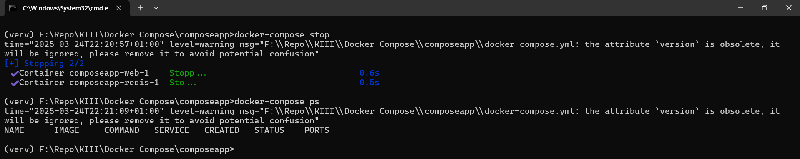

13.Removing the contaniers with rm ( but we could have done the stoping and removing with docker-compose down all in one)
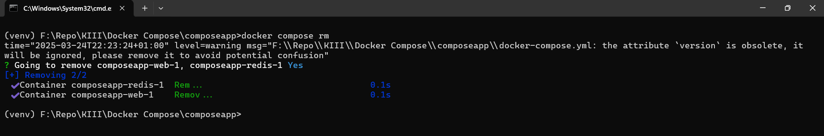
14. The last time checking we dont have anything running

